|  |
| --- |
| Victoria Crash Statistics Data Analysis Executive Summary |
| Harris Huntington, Eric Martin2810ICT Software TechnologiesSeptember 5, 2022 |

# Abstract

After running each aspect of the analysis program with a one-year time frame, the following information can be inferred.

More crashes are likely to happen between the hours of 3pm and 7pm. There isn’t a strong relationship between the day of the week and the number of crashes that occur, however there is a strong relationship between the number of crashes involving alcohol and the day of the week. During Friday, Saturday and Sunday, it is almost twice as likely that a alcohol involved incident will occur. However, the total number of accidents caused by alcohol appears to be in decline.

# Introduction

The purpose of this report is to provide summaries of the analysis performed by the application created. The tasks that were required are as follows:

1. Display all information of accidents that occurred within a user defined period (days)
2. Produce a chart showing the number of accidents in each hour of the day.
3. Retrieve all accidents which match a user inputted keyword, such as ‘Pedestrian’ or ‘Collision’, within a user defined period.
4. Show the user an analysis of alcohol impact on accidents, show by charts of:
   1. Number of accidents involving alcohol per year.
   2. Number of accidents involving alcohol by weekday.
   3. Number of accidents involving alcohol by type of accident.
5. Produce a chart showing the number of accidents by weekday for a user defined period.

The data range used for each of the summaries will be 1/1/2014 – 1/1/2015 for all tasks except the yearly alcohol analysis, which will have the date range 1/1/2014 – 31/12/2018, and the other alcohol related functions, which will review the entire csv file.

# **Analysis 1: Accidents within user defined period**

The first required task is to display the information of all accidents that occur with a user stated time frame. As can be seen in Figure 1, the dates selected are 1/1/2014 and 1/1/2015. With the ‘All’ radio button selected, clicking search provides all the data from crashes in 2014. A sample of this data can be seen in Figure 2.

Figure

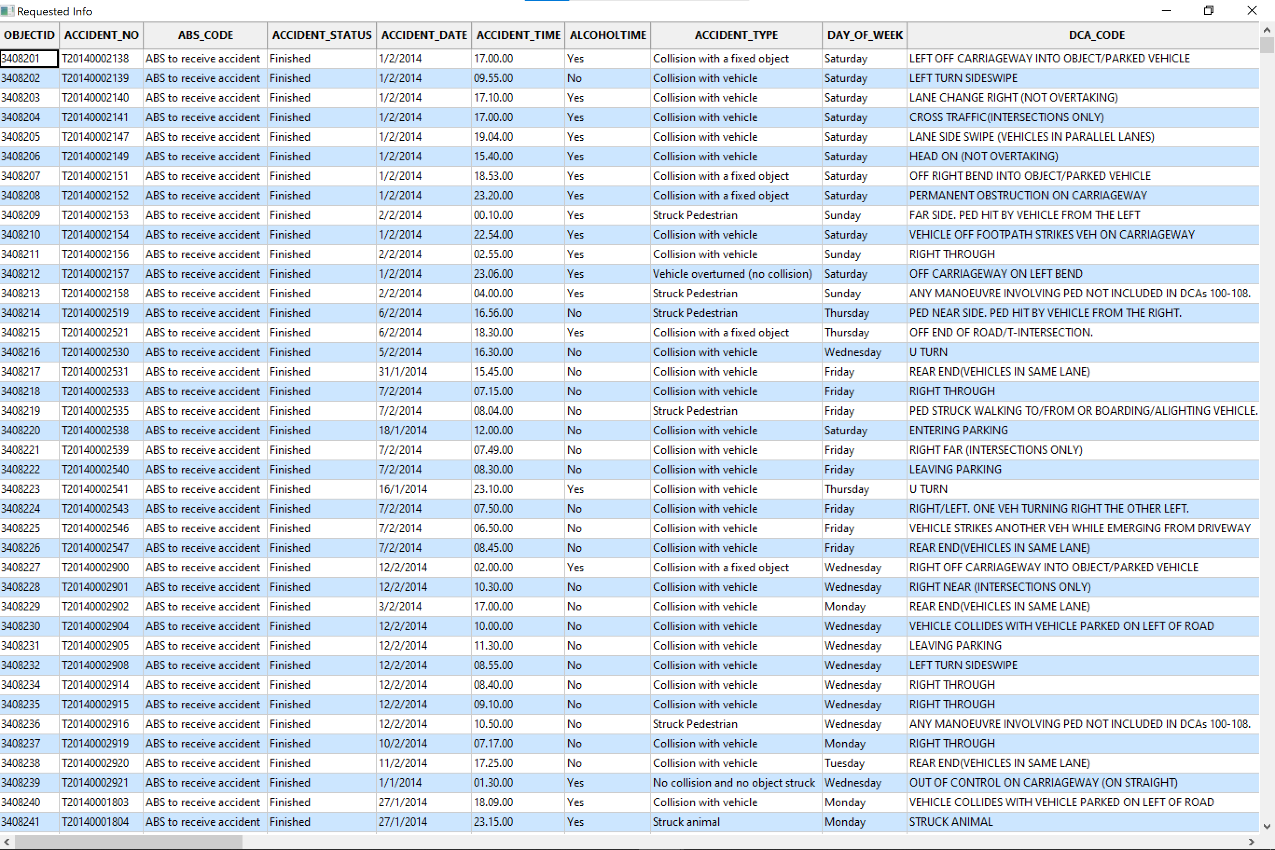

Figure

# **Analysis 2: Chart of hourly accidents**

The second task required a chart to be produced which displays the number of accidents that occur each hour of a day. Figure 3 shows the inputs, and the produced chart can be seen in Figure 4.

Judging by this data, more crashes occur on average in the mid to late afternoon, with 5pm being the most common time for a crash to occur. This makes sense, as more vehicles tend to be on the roads between 3-7pm due to the school/work day finishing.

Figure

Figure

# **Analysis 3 Find Accidents with keyword**

The third task was displaying all information on accidents which contained a user-inputed keyword in the ‘ACCIDENT_TYPE’ attribute. Figure 5 shows an example with the keyword ‘Pedestrian’. A sample of the results can be seen in Figure 6. As shown, only accidents with the word ‘Pedestrian’ in the ‘ACCIDENT_TYPE’ column are being displayed.

Figure

Figure

# **Analysis 4 Alcohol Impact Analysis**

The fourth task is made up of three subtasks: A yearly trend, a weekly trend and type of accident trend of alcohol impact. The yearly trend (figure 8) indicates that the number of drink driving is going down, judging by the last 2 years on the chart.

The weekday chart shows that many more people drink and drive on the weekend, as the number of accidents on Friday, Saturday and Sunday are far above the other days of the week. This is to be expected, as more people tend to drink on the weekend due to not having to work.

The Accident type trend chart shows that out of all the different types of accidents to occur when alcohol is a factor, a collision with another vehicle is by far the most likely to occur. This might be due to alcohol, but it is also likely that this is just the most common type of accident in general.

Figure

Figure

Figure

# **Analysis 5 Weekday Statistics**

For a user defined period, a graph can be produced which shows the number of crashes per weekday. This data (Figure 10) gives the impression that there is not much of a relationship between the day of the week and the number of accidents, as most days have a similar amount.

Figure